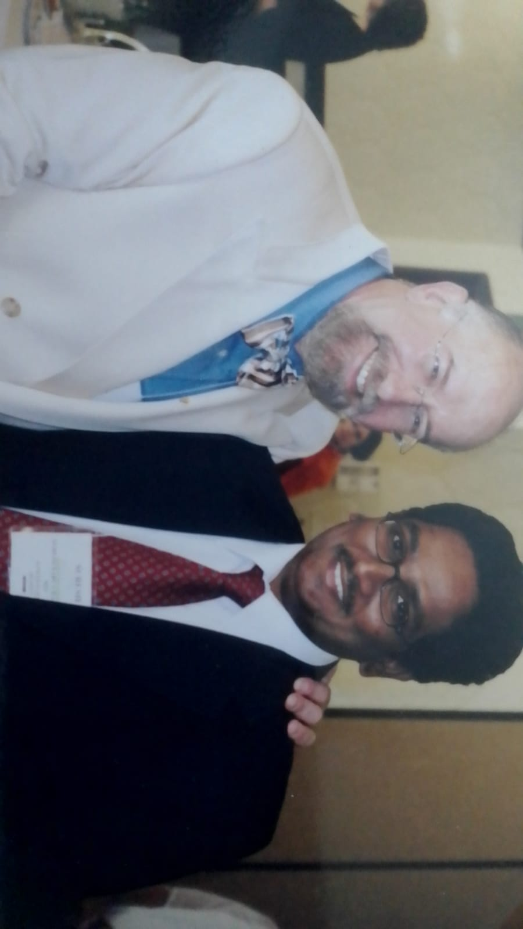

Dr. Suresh with American Urogynaecology President

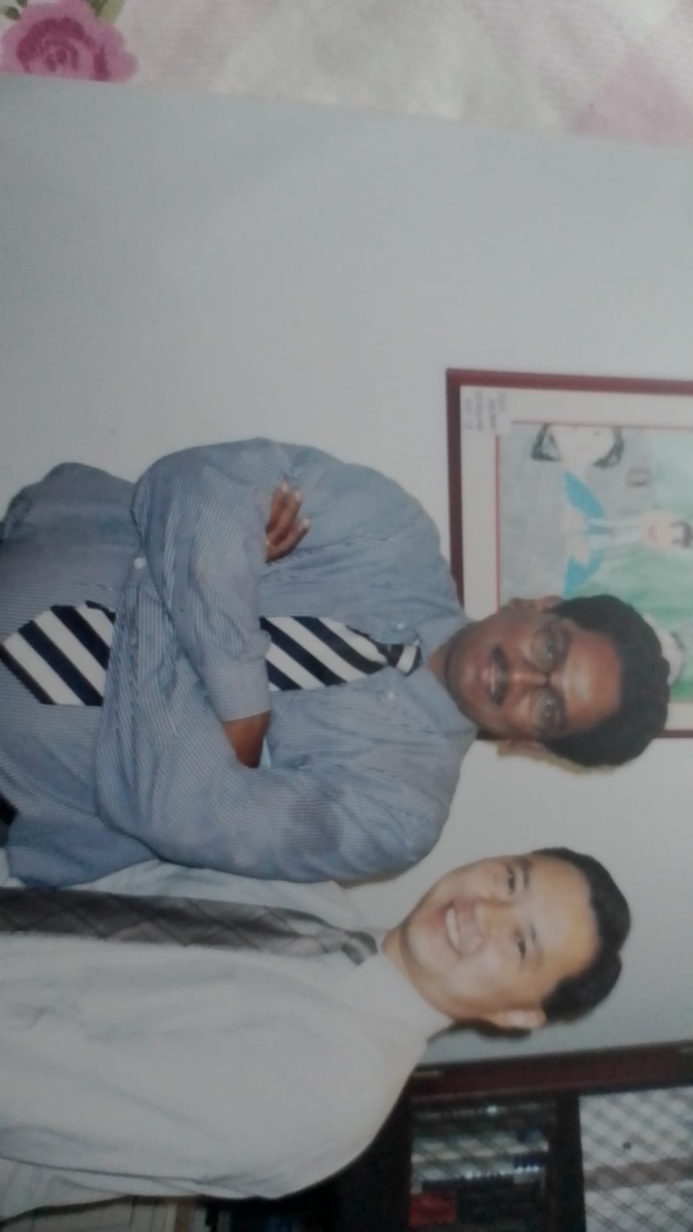

Dr. Suresh with Prof. Chi Li

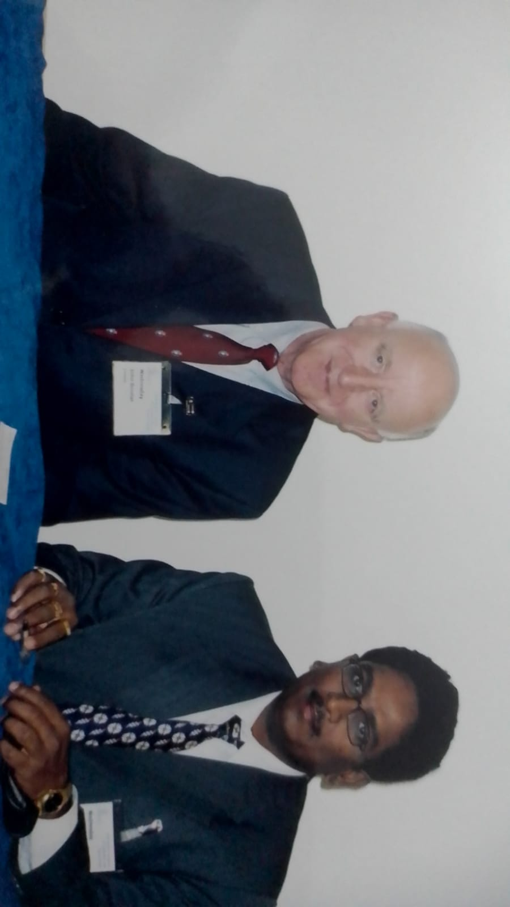

Dr. Suresh with HOD Gynae Oncology John Victor Bonney Memorial **Sloan Kettering Cancer Centre New York.**

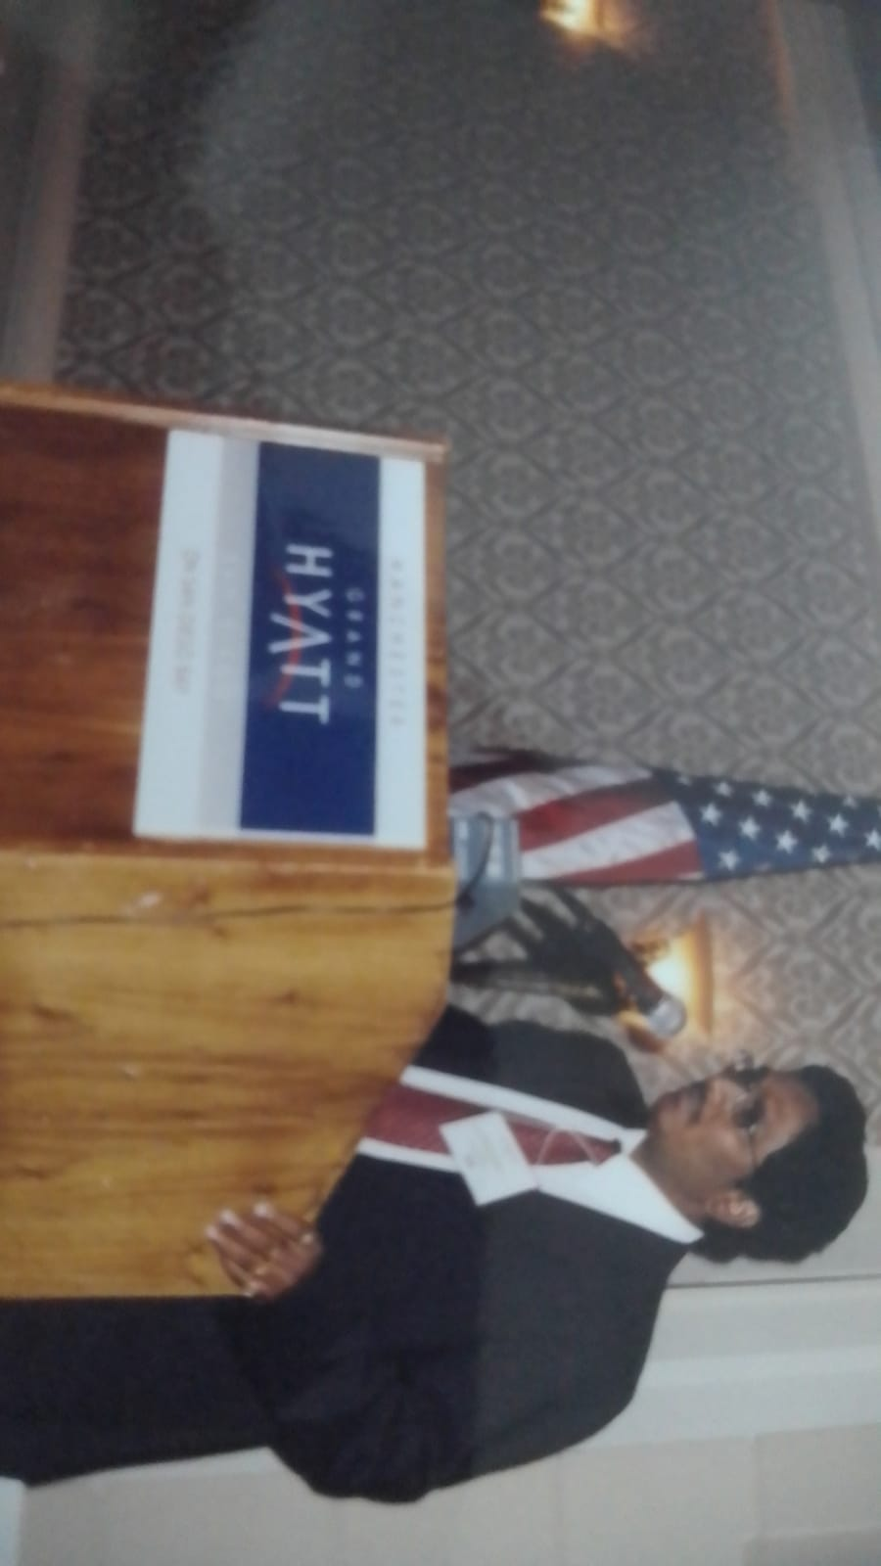 Dr. Suresh presentation at AUGS Conference

at San Diego California.

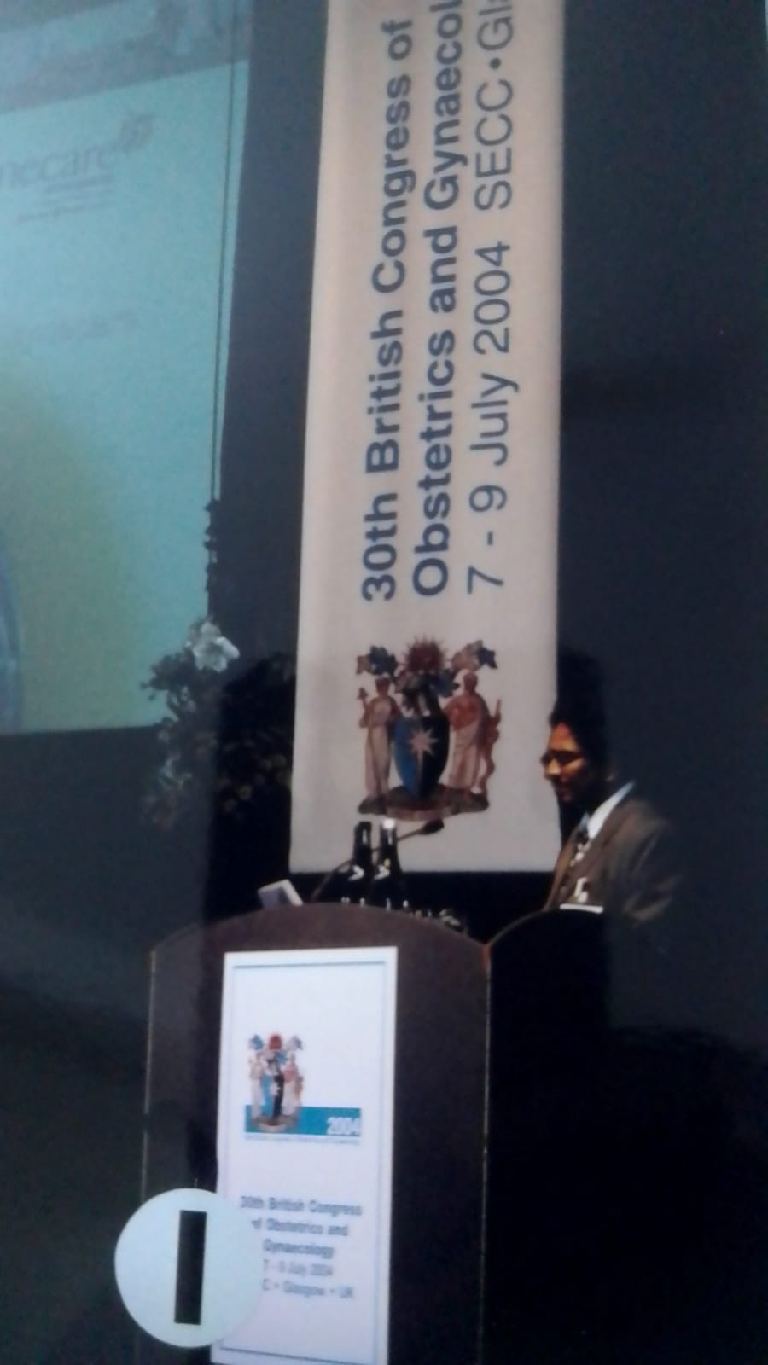

Dr. Suresh Presentation at Glasgow Scotland

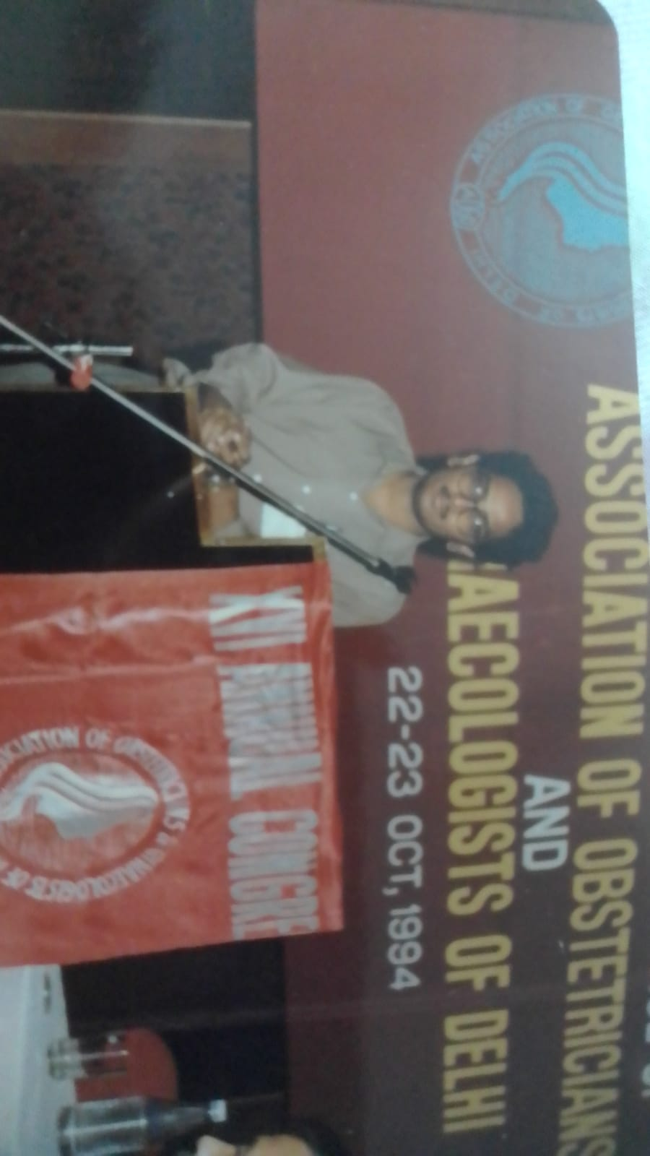

Dr. Suresh during his M.D course AIIMS New Delhi

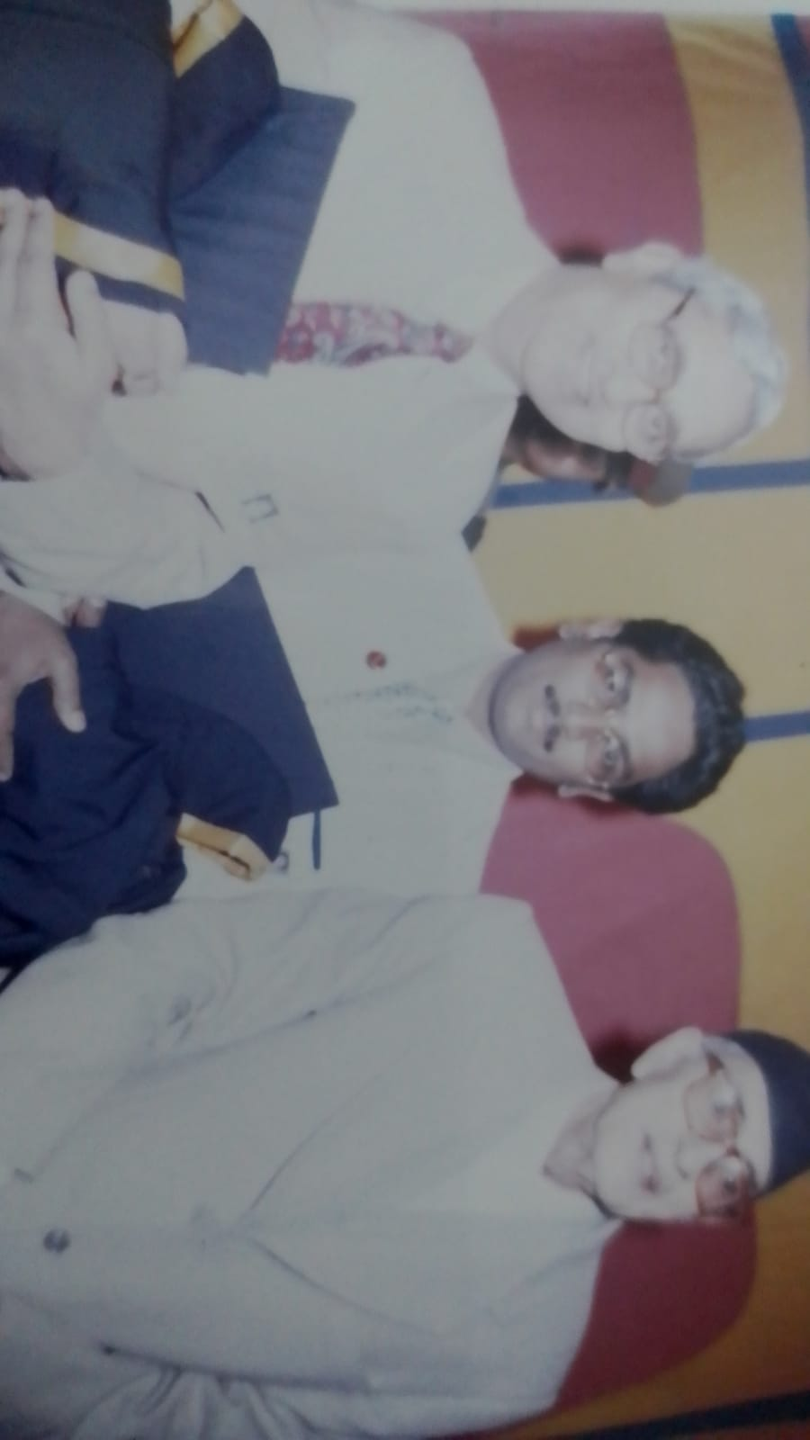

Dr. Suresh in Nepal with Sri Girija Prasad Koirala 2000

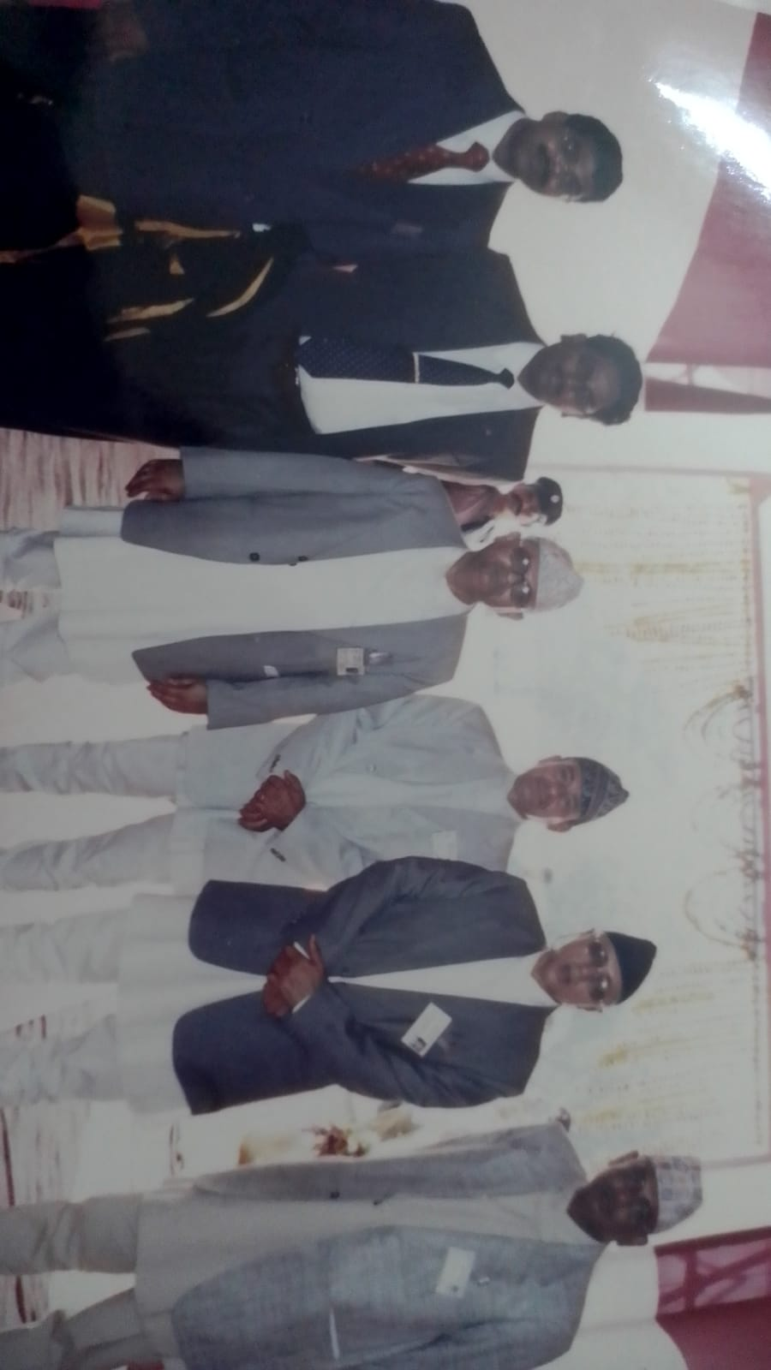

Dr. Suresh with Pri minister Sher Bahadur Deuba in 2001

BP Koirala Institute of Health Sciences Nepal

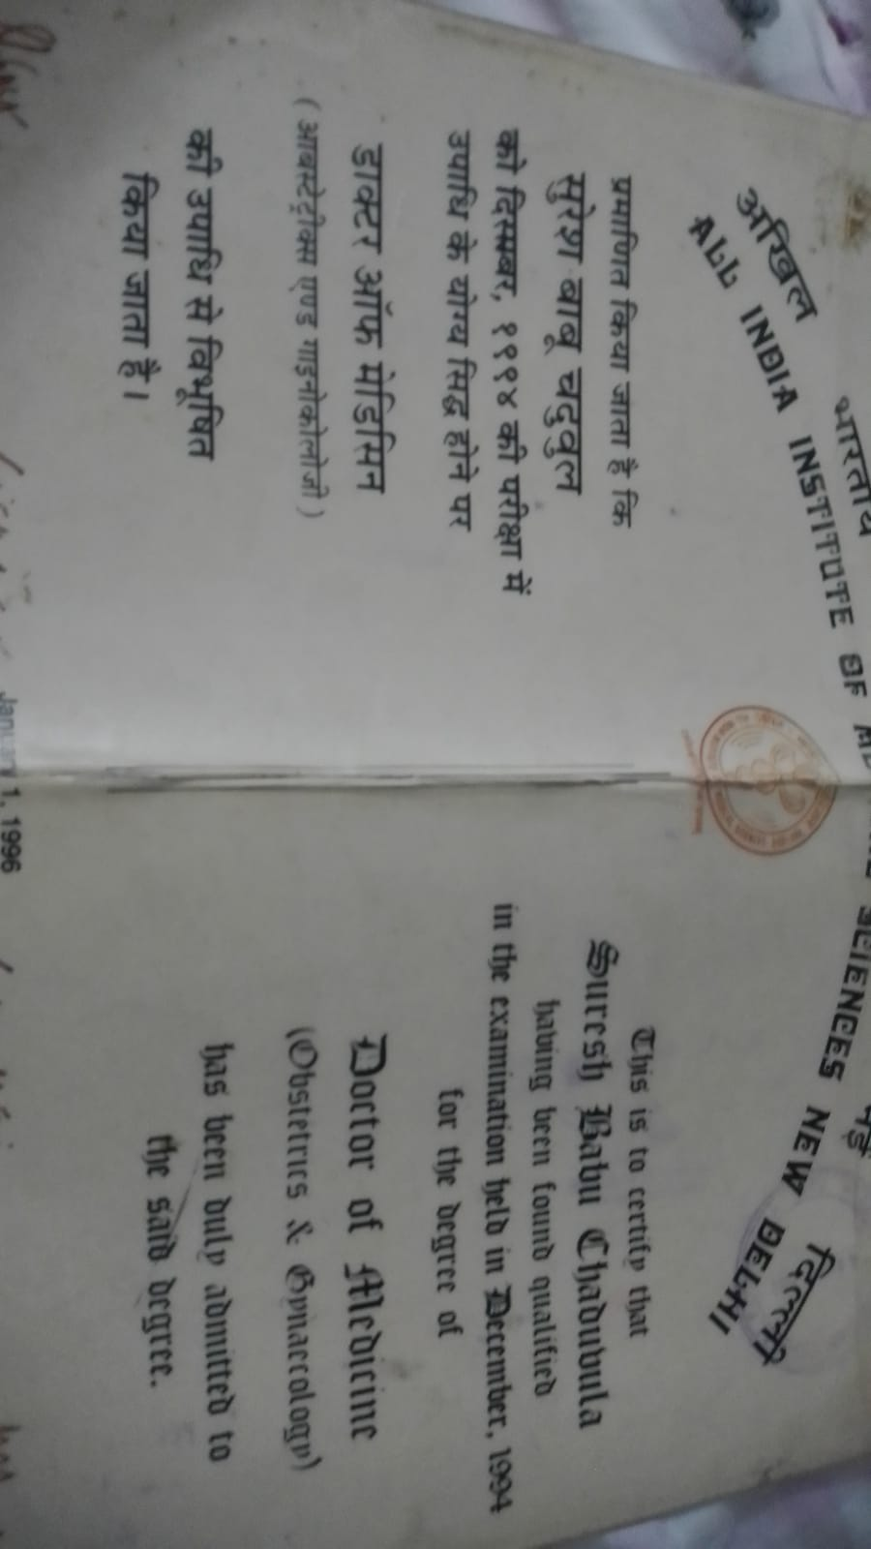

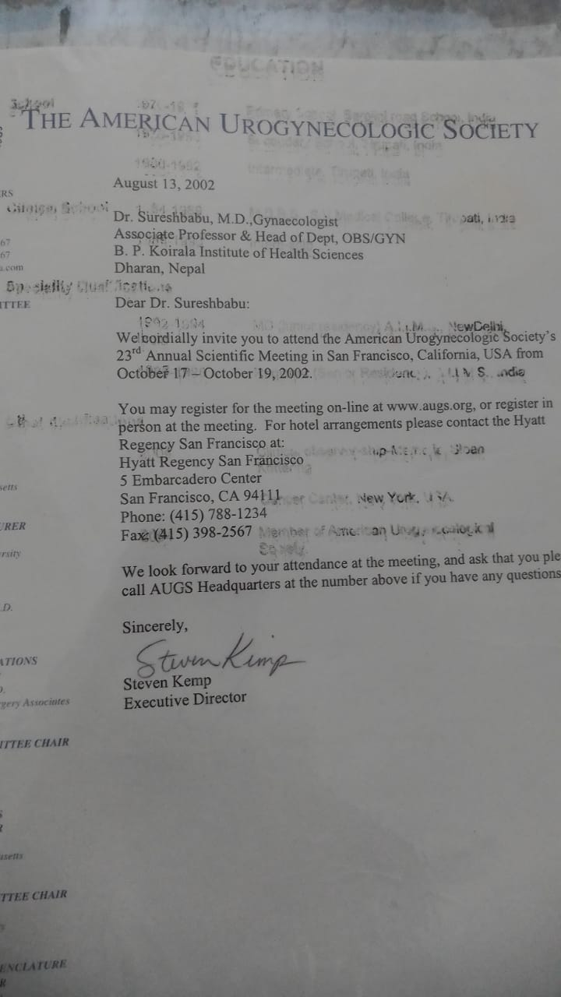hi You can avail Chaduvula Suresh Babu Power point presentations in Slide share.net